Judge Project: System Architecture and Implementation Plan

Introduction
This document outlines the architecture, scope, and implementation roadmap for the Judge Project, which automates code assessments for school labs. The goal is to streamline the grading process for teachers by safely executing and evaluating student code.
Audience
Developers, Teachers, and Project Managers

Project Scope
- Core Functionality:
  - Students: Can submit lab assignments (code) for evaluation.
  - Teachers: Manage lab assignments, review submissions, and manage enrolled students.
  - Admins: Full control over papers, labs, users, and submissions.
- Key Components:
  - Backend: ASP.NET for authentication, validation, and API endpoints.
  - Frontend: React application for user interfaces.
  - Execution Sandbox: Docker container with a Flask API to safely run submitted code.
  - Database: MS SQL to store users, papers, labs, and submissions.

System Overview

Architecture:
User Interface (React) | Interfaces for Students, Teachers, and Admins
Backend API (ASP.NET) | Handles business logic, user management, and communication with the execution sandbox
Execution Engine (Docker + Flask) | Receives code via a DTO, executes it in isolation, and returns the result
Database (MS SQL) | Stores and updates system data

Data Flow
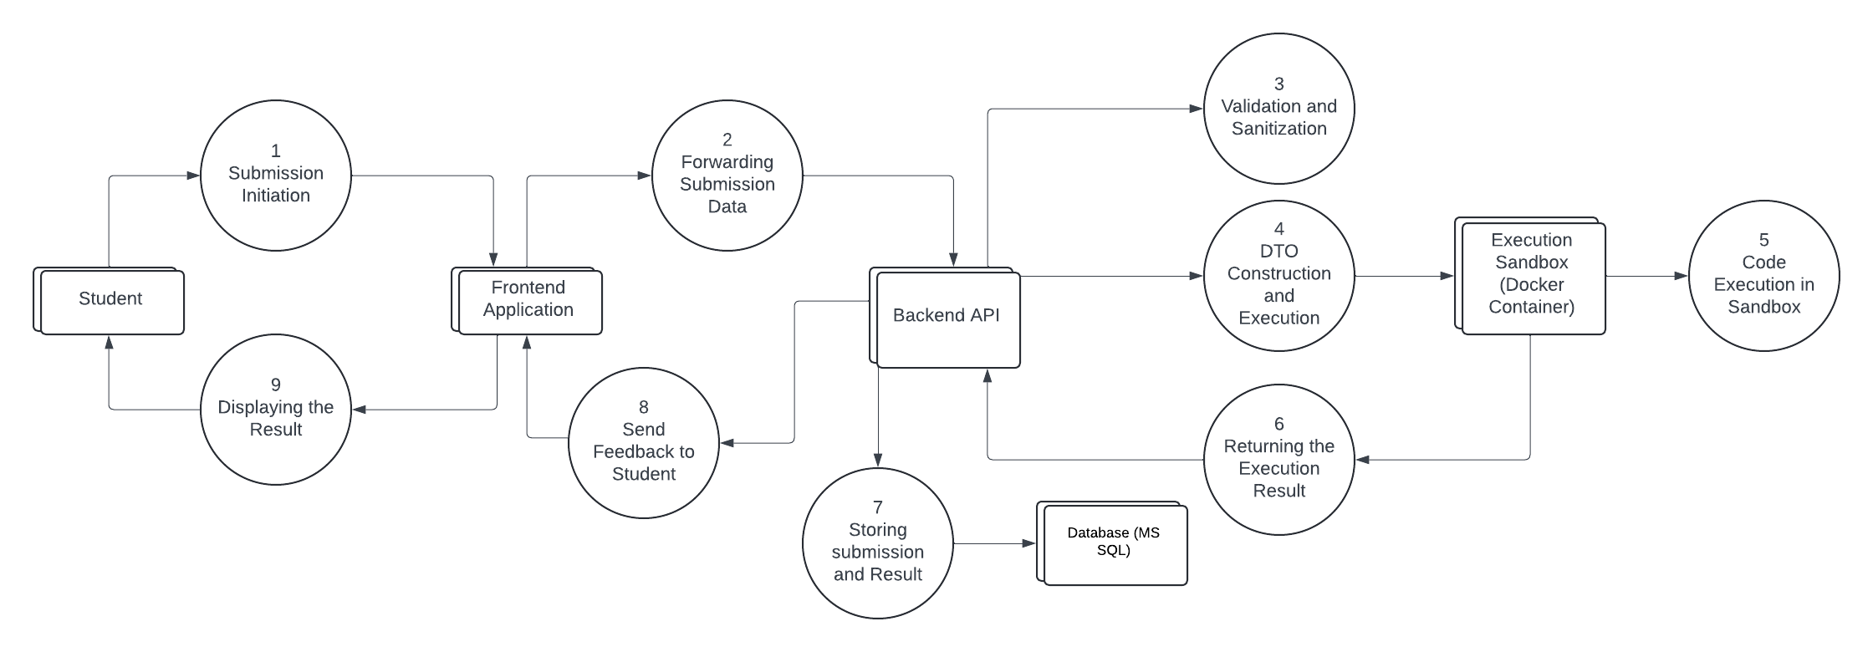
Student → Frontend (React): The student initiates the process by submitting lab code.
Frontend → Backend (ASP.NET): The frontend sends the code and lab identifier to the backend.
Backend Internal Process: The backend validates and sanitizes the submission.
Backend → Execution Sandbox (Docker/Flask): The backend sends a Data Transfer Object (DTO) with the sanitized code, language, lab input, and expected output.
Execution Sandbox Internal Process: The sandbox executes the code safely and captures output and errors.
Execution Sandbox → Backend: The sandbox returns the execution result (Success, Error, or Failed) to the backend.
Backend → Database (MS SQL): The backend stores the submission details and the execution result.
Backend → Frontend: The backend sends feedback to the frontend.
Frontend → Student: The frontend displays the final result to the student.

Implementation Roadmap
Phase 1: Core Functionality (MVP)
- Develop user authentication and role management (Student, Teacher, Admin).
- Implement lab submission and basic validation.
- Set up the Docker sandbox and integrate with the backend.
Phase 2: Advanced Features
- Extend CRUD operations for teachers and admins.
- Enhance security and sanitization for code submissions.
- Implement asynchronous communication with the Docker container.
Phase 3: Optimization & Scaling
- Optimize performance and error handling.
- Add additional languages and code execution rules.
- Prepare for large-scale deployment and monitoring.

Permissions and Roles
- Admin:
  - CRUD operations for papers, labs, users, and submissions.
- Teacher:
  - Manage labs (CRUD) within a paper, view student submissions, and manage students.
- Student:
  - Submit lab assignments and view feedback.

Technical Stack
- Backend: ASP.NET
- Frontend: React
- Sandbox: Docker container running a Flask API
- Database: MS SQL
- Communication: JSON over asynchronous APIs

Deployment & Update Strategy
- Version Control: Use Git to track code changes and collaborate.
- Continuous Integration/Deployment (CI/CD): Automated tests and deployments to staging/production environments.
- Update Documentation:
  - Maintain a Release Notes or Change Log document to track updates, bug fixes, and new features.

